3000GT AEM TUNING GUIDE
Disclaimer: I am putting this guide together based on my experiences with AEM EMS v2 and the 3000gt. I have no special training or certifications in tuning, but I have spent a lot of time on the forums gathering information. This guide and screenshots all apply to the 30-6311 EMS using AEM Tuner software.

My car info:
I drive a 1994 Mitsubishi 3000GT VR-4. It had 55k original miles on it when I wanted to build it. I have a 3.0L block with Ray’s Ross Pistons/Rods/wrist pins. I’m running stock head gaskets, stock headstuds (new studs torqued a few ft/lbs tighter than stock spec), and port/polished heads. All of the machine work was done by Dave Edgar in Ware Mass. He is popular among the New England DSM/Evo crowd and has very reasonable prices.
I’m running stock headers (ported where the fire ring would be), dr750 turbos w/ billet wastegates (blue spring), 1000cc PTE injectors, hot wired aeromotive fp, aeromotive fpr aem ems v2, aem meth w/ 800cc cooling mist nozzle, custom fmic and piping, tial bov, blitz dsbc, MSD 8.5mm wires, NGK Iridum’s with a 0.025 gap, hks ignition amplifier, ips intake pipes w/ aem dry flow filters, 3” downpipe, and a 3” borla catback. Looking back I wish I had done the headlift fix by Pampena motorsports. I didn’t even know about it at the time. Going along with AEM EMS I also have an aem wideband gauge, IAT, and 3.5 bar MAP sensor.

Break-in info:
It’s never a good idea to break an engine in on an ecu setup that you are unfamiliar in. Trying to learn aem and break in the engine was not worth the risk of my engine. So when breaking it in I used my stock ecu and stock 360cc injectors. I ran wastegate pressure, and used a stock intake box with stock maf. I used cheap Castrol gtx oil and did a lot of engine compression braking so that the rings would seat right. I ran it like this for about 1000 miles and did 4 oil changes. (after warmup, after 10 miles, after 100 miles, after 500 miles). Then I switched over to aem. Currently I am using Brad Penn 20W50 and do oil changes around 2500 miles, sometimes earlier.

Wiring IAT and Map sensor
The installation instructions that came with AEM do a good job at showing the wiring diagram for this, so I’m just copying it here. Just triple check everything and make sure you are looking at the connectors the right way when determining the left/right side I have a slightly different AEM gauge that the diagram below. Mine is P/N 30-4100 so mine only had 4 wires.
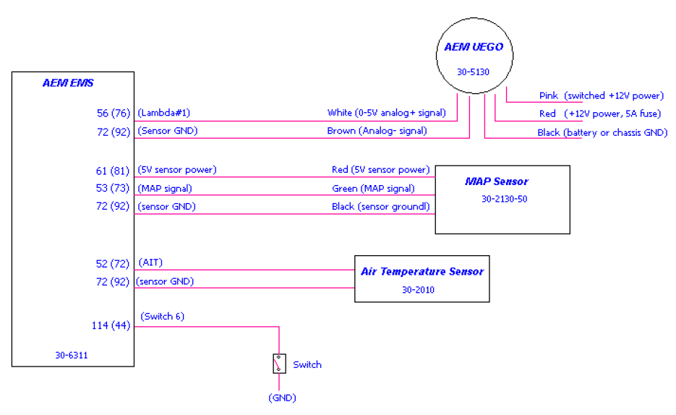

And here is the individual pin-out. This should have come with the unit, but you can also get them online here. Be sure to check the FAQ section at the bottom of this guide as well because some of the pins listed in AEM’s guide are wrong:
http://www.aemelectronics.com/Images/Products/Installation%20Instructions%2030-6311.pdf

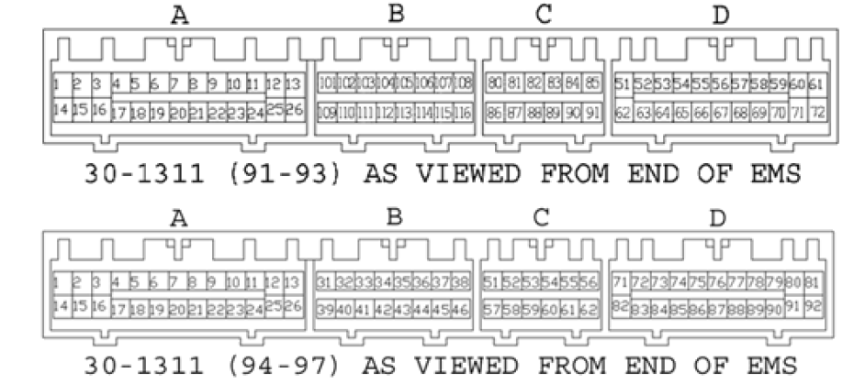

Get your car Ready
Make sure that you have everything in order for tuning. A boost leak test is important. I tested mine up to 30psi. Make sure your plugs are gapped correctly. If your car is smoking at all after break in then you may want to do a compression test. Make sure your base fuel pressure is set correctly (43.5 psi). If your plug wires are old or stock, upgrade them. Make sure any 60k/120k services are done, and that your fuel filter isn’t old.

Configuring AEM

Downloading a base map file
You can download this straight from AEM’s website. It’s basically something to get started with. I grabbed the 2nd one which is a v17 file.
http://forum.aempower.com/forum/index.php/topic,26431.0.html

Upgrading firmware and .Cal files
Now if you are starting with the v17 calibration file above, it most likely won’t work right away with your AEM Ecu. They come shipped with a later firmware version. Mine came with v24 firmware. The calibration file version needs to match the firmware version on the ECU. So you have 2 options. I used option 1 initially and after I got familiar with AEM I did option 2.
Option 1: Just keep the v17 file for now and change/revert the firmware of the ECU back to v17. You can do this by going to ECU->Upgrade EMS Firmware…
Option 2: Upgrade the v17 EMS fie to the firmware version. You can do this by opening the .cal file and going to Tools->Upgrade Current Calibration. Then select the version and click “convert.”

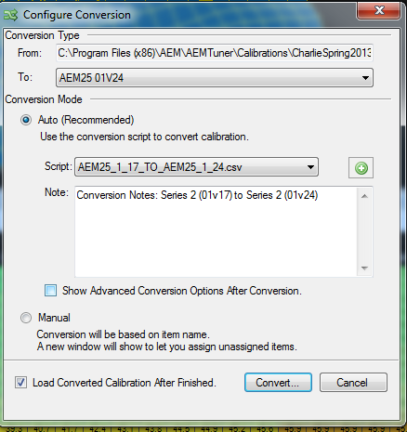
After it converts it will ask you to save the file. It will also tell you what was converted.

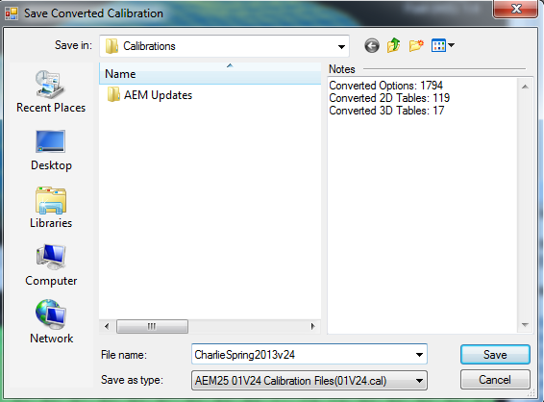

AEM tip – show help on
When you open AEM to begin configuration the first thing you should do is turn on Tuning Explanation. It is under the Help menu. It will add a help pane on the right hand side of the screen. Basically it will give you a detailed description of any field you highlight in the app.
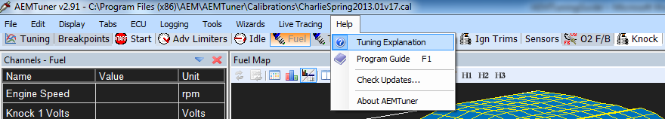

Tps wizard
With the ECU connected and the car off, we can set the throttle range. The stock throttle position sensor reads between 0-5 volts. However it’s not exactly 0/5.0 volts. Every car is different. Pedal travel, throttle cable tightness, cable stretch/bends will make the voltage vary. So in this wizard you need to press the “Set TPS Volts Min” button with the pedal depressed. Then press the gas pedal down and hit the “Set TPS Volts Max” button. If you are not seeing approximately 0 to 5 volts double-check your map sensor wiring. I actually had 2 of my wires crossed and it caused my TPS to go from 0-2 volts initially. You could also have a faulty TPS sensor. I had a sensor go bad on me and it would only read to 4V.
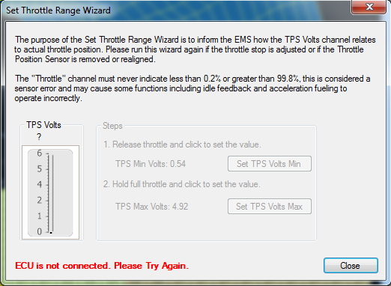

Calibrating AEM wideband
A common problem with AEM is that your wideband gauge will read differently that the AFR in AEM. With the AEM gauge the signal is sent to the gauge, and then it is sent to the ECU. So if the gauge is reading 14.0 and the logger is showing 12.3, you need to calibrate the gauge.
First make sure you have the correct wideband gauge set in the wizard. AEM has a few different wideband gauges. The back of the gauge should have a part # on it. Then we need to test the calibration. With the car off unplug the connector on the back of the gauge that connects to the physical wideband sensor. This will make it read a steady 14.6. (This is true of AEM wideband gauges, other brands may differ)
Then in AEM open the o2 cal table and keep an eye on the o2 #1 channel. If the AFR differs from the gauge, then we must adjust the entire table. Fortunately it is linear, so highlight the entire table (really just 1 long row) and adjust the entire thing up/down until the gauge matches the afr in aem.

*Note: AEM also makes small adjustments. So while on the cell it shows 14.6 you may be able to click +/- 3 to 4 times and it will still show 14.6. This is because it’s really making decimal changes that you can’t see. So split the difference. If it matches the gauge on 14.6 and you can hit + 4 times before it jumps to 14.7… then go back and hit + 2 times so you will be in the middle.

Other Wizards
Under Wizards->Setup Wizards there are several things to setup.
Feedback: Boost Control – I don’t use this, but AEM can control boost if you wantd it to
Feedback: O2 control – I use this. I have it set to AEM (Gauge) UEGO Sensor. You do not need this set for now, but may have to come back into this wizard later on if you decide to use O2 Feedback.
Ignition: Coil Dwell – Set to Mitsubishi 3000GT (1991-1997)
Injectors: Primary – Mine are set to Precision Turbo 1000cc (95lb) 2 ohm
Injectors: Staged – I don’t have this set. For complicated setups though you could run 2 sets of injectors.
Rev Limit: 2 step – This will prefill some of the 2step rev limits. Don’t set this, we’ll do it manually in the NLTS section
Rev Limit: Main – Same as above. We’ll adjust this manually later on
Sensor: Air Temperature (AIT) – Mine is set to AEM AI Sensor (PN 30-2010) It also auto selected a M sensor too when I set this. Not sure why, probably a bug.
Sensor: Cam/Crank Position – Set to Mitsubishi 3000GT (1991-1997)
Sensor: Coolant Temperature – I never set this, but there are 2 mitsubishi ones. My coolant temp seems to read fine. <need to come back here>
Sensor: Exhaust Gas Temp – I’m not using this, but aem could log EGT if you wanted it to.
Sensor: Manifold Pressure (MAP) – Mine is set to AEM 3.5 Bar (PN 30-2130-50). This is good up to ~30-35psi). If you plan on running more boost you should use the 5 Bar one.
Sensor: Mass Air Flow (MAF) – Not set
Sensor: O2 #1 (AFR) – I have this set to AEM Digital Gauge (PN 30-4100) as that’s my wideband gauge and I have it wired into this pin. For some reason when I go back into the wizard it shows me as having nothing selected here. It just doesn’t save as bold, but it’s set Another bug.
Sensor: O2#2 (AFR) – I do not have this set. But if you are using 2 wideband sensors (1 for front turbo, one for rear), or you wired your single wideband into the O2#2 pin, you’d need to set this. I use a single wideband in my downpipe after the Y, and it’s wired into O2#1.
Sensor: Vehicle Speed (VSS) – Set to Mitsubishi EVO VIII; DSM 2G; 3000GT
Setup: AEMNet Receive – not set
Setup: Automatic Transmission – Not Set
SETUP: Variable Valve Control – Not Set
Telemetry: AEMNET - Not Set
Telemtry: Serial – I have this set to 01v17 AEM Serial Datastream. This is because I’m using an AEM serial gauge. Just like the O2 wizard option, this doesn’t stay bold either.

Verifying Coils/Injectors
You will probably have to go to Tabs->Hidden tabs to find the “Coils/Injectors” tab. The 3000gt specific maps that are on AEM’s website have these configured properly already; so this is more of a double-check. Make sure all 6 injectors are active. Make sure they are tied to Knock Sensor #1. The injector type will be base. The O2 feedback column associates an o2 sensor to a given injector. If you are not using o2 feedback then you do not need to worry about this. If you don’t know what it is, don’t worry; we will go over it later on. Just be aware that these settings are here. You don’t need to set the o2 feedback to be able to start your car.
If you are referring to this screen to setup the o2 Feedback, it’s pretty straight forward. I am using a single wideband after the merge in my downpipe so all 6 injectors will use this solo O2 #1 wideband sensor. If you were running dual widebands (1 for each turbo), then you would want to set the injectors correctly so that the front 3 injectors use the front O2 and the rear 3 injectors use the rear O2 sensor.
The coil section should use the first 3 coils as shown in the screenshot. I wouldn’t change anything here unless you really know what you are doing.
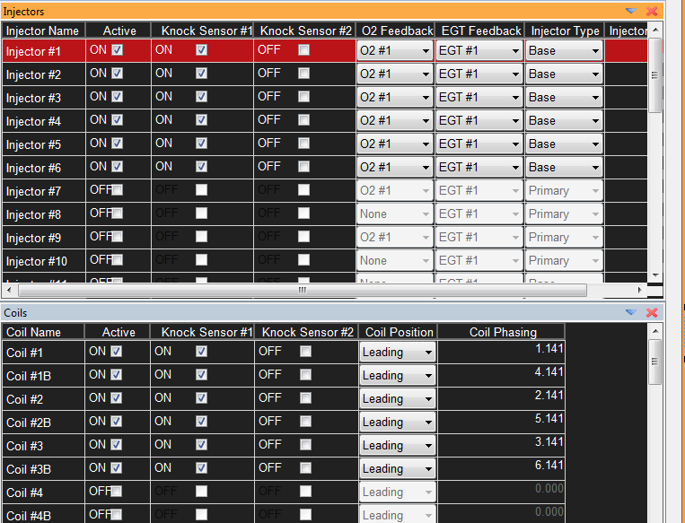

Starting Car for the first time
Make sure “Knock Control” (Knock tab) and “O2 FB Control” (Fuel Tab) are both off. We will go over these later on, but while starting your car for the first time we do not want them interfering with anything.
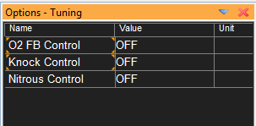
At this point you can try starting your car and letting it warm up. Keep an eye on your wideband gauge. It normal for it to run a little rich when warming up, While it’s running have open the Fuel tab. You will see exactly what cell(s) it is reading in. If the afr starts reading really rich/lean (like bellow 11 or above 15) you can adjust the group of cells around where it’s idling. Keep babysitting it until the car is warmed up.
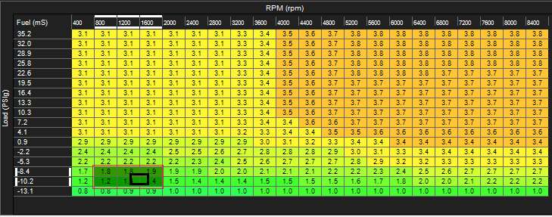

Synching timing
Now that the car is idling you need to synch the timing. There is a wizard for this under Wizards -> Ignition Timing Sync Wizard. The first thing to do in the wizard is click the “show advanced options” checkbox at the bottom. The Pickup Delay Comp needs to be set. The 1g vr4s use a different cam sensor than the 2gs. On a 1g it’s attached to the rear head near the throttle body. On a 2g it’s attached to the rear head underneath the timing covers. For a 1g vr4 the Pickup Delay Comp should be set to ~50 microseconds. For a 2g it needs to be set for ~130 microseconds. Once this is set you can start to synch the timing.

You will need a timing light to do this. They are around $100 or so at your local auto parts store, but maybe you can borrow/rent one. A lot of DSM owners who do 6 bolt swaps will have one or know where to get one. The timing light will have 3 wires coming off of it. One is power; one is ground, and the other clamps on to your #1 spark plug wire. When the plug sparks the timing light will flash. It’s like a strobe light. The factory lower timing cover will have marks from 0 to 15. In AEM lock it at 5 degrees then use the timing light to make sure it’s flashing when the crank pulley mark is at 5 degrees on the timing cover. If it’s off you will have to increase/decrease using the wizard. After setting it at 5 degrees, I locked mine at 10 degrees just to double-check using a different number.
Once it’s set at idle you can keep it locked and rev the engine. You want to confirm it’s still correct at higher rpms. If it is off at higher rpms, you may have to fine tune the pickup delay comp some.
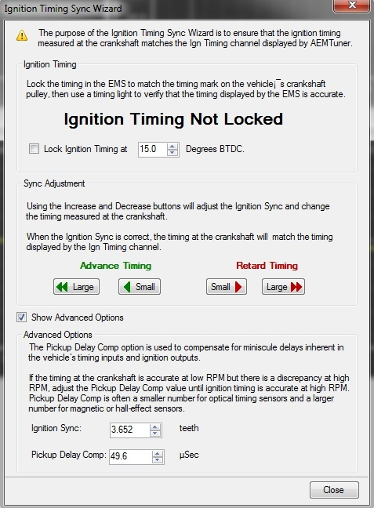

Rescaling Tables
The default table scaling AEM gives you would work, but it’s not ideal. You are never really going to rev above 7-8kish rpms. So having 6-7 columns going up to over 10k rpms is a waste. You are better off having more rpm points that you can use for fine tuning. I set my rpm points to be every 400 rpms. You will want to do this on the Fuel table and the ignition table. AEM will automatically rescale everything in the table correctly. (I actually spent over an hour rescaling it myself ahead of time in excel, only to be amazed by aem).
Before:
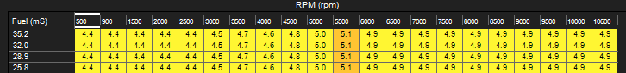
After: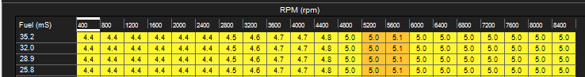

Startup tables
Personally I do not have any good techniques on configuring this yet, but hopefully soon. Let’s talk about the tables though. AEM does a good job describing these, but I’m going to go through it as well.
Fuel Pump Prime: 2 seconds – When you turn your key into the on position it will prime the fuel pump. This builds pressure in the fuel lines so that it’s readily available when starting the car.
Crank Advance: 5.1 degrees – The ignition timing is locked on this value when the car is cranking.
Crank Inject All: Yes – This will fire all the injectors at once? “batch fire” is how aem describes it <need to look into it>
Crank Min RPM: 50 rpm – Once the engine reaches this minimum RPM, AEM will think the car is starting and not refer to the startup tables that I will describe below.
Crank Max RPM: 500 rpm – Once the engine reaches this RPM AEM exits the starting mode tables.
A/C Min RPM: 500 rpm – This is the minimum RPM for the A/C to be enabled. So if you have you’re a/C on, shut the car off, and go to start it later; the A/C really won’t come on until the car is considered “started”.
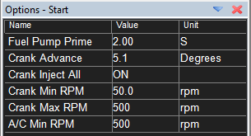

Initial Crank Pulse Table: When your car first begins to start this is a single pulse made to all 6 injectors depending on temperature. So when the car RPM exceeds the Crank Min RPM (shown above as 50 rpm), the first thing the ECU will do is fire all 6 injectors for X amount of time. So in this graph if the coolant temperature was 50 degrees, all 6 injectors would fire once for 12.1 ms.

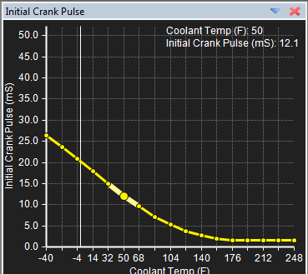
Crank Injector Time Table: Once the initial pulse finishes, the amount of fuel that the injectors fire starts at this table and is based on the TPS (how much, if at all you re pressing the gas pedal down) The first few values are for if you do not want to feather your gas pedal at all. As you give it more throttle, more fuel is injected. Most people make full throttle drop to 0 fuel. So if you flood the engine, you can push the gas pedal to the floor and the car won’t deliver more fuel; just spark. Or maybe you want to crank the car over and don’t want it to start, you can push the pedal down instead of having to pull the ECI fuse. If you notice that sometimes your car doesn’t want to start, but you press the throttle 100% and it starts; then it’s a sign that one of the startup tables is defined as too rich.
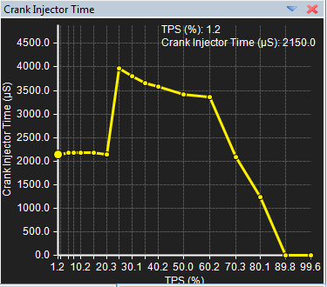

Start Extra vs Temp Table: This really builds upon the above table. The table above gets modified by X percentage based on the coolant temperature. So when it’s colder we will add a greater percentage of fuel. When the coolant temp is hotter, we will not tweak it as much.
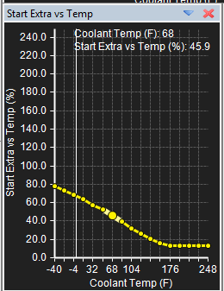
Start Extra Decay Table: This goes hand in hand with the above table. It defines how long we make these percentage adjustments. This is based on coolant temp as well. So the colder the temperature, the greater percentage of fuel we add, and we keep adding that fuel for a longer period. A hot car we don’t add a whole lot of extra fuel, and we don’t add it for very long.
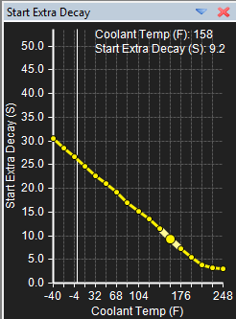
Warmup Enrichment Table: Now once the car is started (RPM exceeds 500), the car needs to warm up. If it’s not a hot start then more fuel is added. This is why you’ll notice it takes a little while for your car to idle at ~14.7 afr when you first start your cold car. For hot starts, if the temperature is greater than 176 F, then it doesn’t take long at all to stabilize at ~14.7 afr.
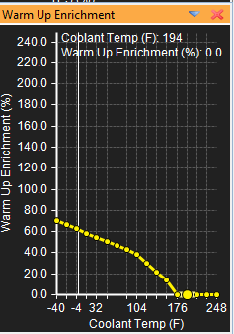

Setup Conclusion: At this point AEM is installed. Your car will start and idle. This would be a good time to double check your sensors in AEM. Make sure it reads coolant temp correctly, make sure the afr shows and matches the gauge while the car is running, make sure your MAP sensor reading makes sense etc… Your car would be at a point now that you could drive it up on a trailer and bring it to a tuning shop. But if you want to keep going I’ll share more below.

Tuning

Now the section above was kind of done in a linear fashion from start to finish for prepping your AEM ECU to be tuned. Everything in the tuning section is more or less in order as well, but I would READ through EVERYTHING before you start making changes. It’s important to understand the big picture. For instance, while you do tune your fuel table before doing your timing table; you need to be sure that your timing table is safe before you begin tuning fuel.

Logging

In order to set you fuel and timing tables we must understand logging first. AEMLog is the name of the program that comes with AEM Tuner. You can access it from Tuner, from the Windows Start menu, or it will automatically open up after you save a log after “Stop PC Logging” in AEM Tuner.
The parameters that are available to graph, depend on what tab you are on when in AEM Tuner when you “Start PC Logging”. Only the channels on that tab will be available in AEMLog to graph. This is why I do all of my pulls on the “Tuning” tab. If you need to add another parameter such as “knock 1 Volts” you can easily add that to the channels list by right-clicking and choosing “Insert Channel”. When you get it customized be sure to save the workspace (File->Workplace->Save) if you want it there permanently.
When AEMLog first opens up you will be prompted with a graph setup. The defaults are fine so click the DRAW button.

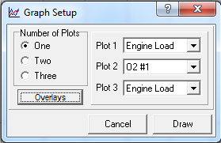
At first the graph will look pretty plane as we aren’t showing anything on it yet.
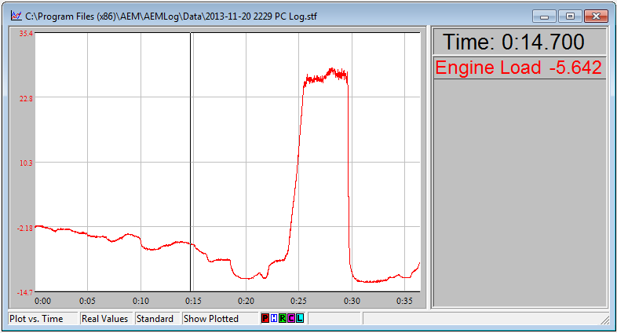
Right-click the graph and select “Overlays”. All of the parameters on the left should match up with what is on the Channels List for whatever tab you were on when doing the pull. Click on the values you want to move them to the right.
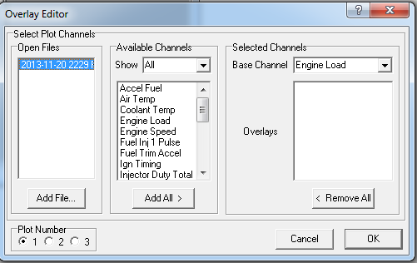

Now it will look more useful. It’s a good idea once you get this set, to go to Templates->Save. Save it so you won’t have to do the overlay setup every time. You can save multiple different templates if you want. If you go to Templates->Configure Templates, the first one in the list is the one that will be loaded by default.

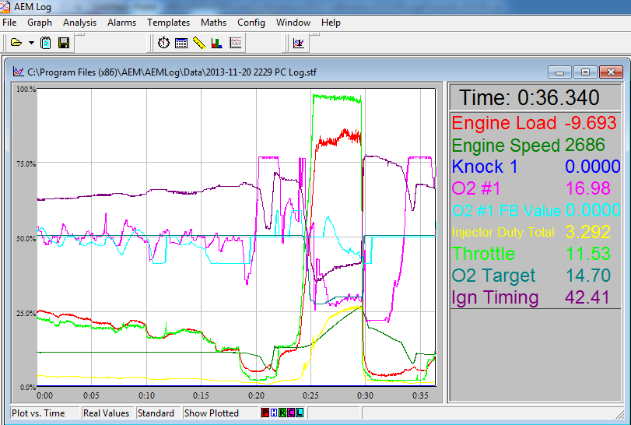

Limiters
This is where you set your redline. In AEM you control when you cut fuel and when you cut timing. There is also a Retard Limit Rev value where it can retard timing at a certain RPM. I’m not using that so I have it set to an RPM I will never reach. The Fuel Cut Load is also important. On the map I downloaded from AEM’s website this was set to 25.0 PSI. It took me a little while to figure out why my car would buck under higher boost. Turns out I was hitting the limiter. I set it up to 35 PSI which is well above what my car will see.
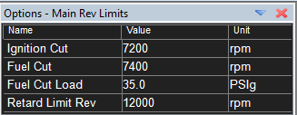

Boost

You can control Boost with AEM. I personally do not as I have a blitz DSBC that seems to work pretty well. Maybe someday I will mess with this and fill it in. Regardless of what you are using, now is where you’d want to set your boost. I would always start out undershooting your boost. So if I wanted to run 25psi, maybe I’d start at 20 psi. Then throughout the tuning process I could always turn it up a little later and tweak my fuel tables again.

Fuel

Deceleration Fuel Cut (DFCO)
When you are cruising and let off the gas pedal there is no need to waste fuel. If you’ve ever watched your wideband on a stock ecu setup you’ll notice that the engine leans right out on deceleration. Well that is what these 4 parameters control. All of the 4 conditions must be set for DFCO to enable.
Fuel Off Above RPM: 1800 rpm – If you are above this rpm then allow the car to go into DFCO.
Fuel Off Below Load: -11.4 load – If you are below this load then DFCO can be enabled.
Fuel Off Below TPS: 2.3 % - If your foot is not pressing the gas pedal more than this percentage, then allow the car to go into DFCO mode.
Fuel Off Coolant Min: 32 degrees F - The coolant temp has to be above 32 degrees to go into DFCO.
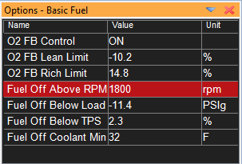

Main Fuel Table
This is under the Fuel tab. The numbers in the graph are in milliseconds. Under a given load and RPM value, the injectors will stay open for X amount of milliseconds. The larger the number, the longer the injector(s) stay open and the richer the mixture. The lower the number, the less open the injector, and the leaner the mixture.
This table is adjusted with the help of your wideband. Your wideband reads the air to fuel ratio. At idle and low load areas of the fuel map (-13 to ~ 0 PSI load) you would want a 14.7 AFR. This number is the stoichiometric value for gasoline, meaning it’s the ratio of oxygen to gasoline to provide complete combustion. This would be 14.7 parts of oxygen to 1 part fuel. You could also see this written as 14.7:1 If you were seeing a higher number like 15.1, then you are running more lean. The lower the number the richer the mixture.
As you start getting into boost and into positive load you want to add more fuel. Under high load when you have the gas pedal mashed; you want to be around 10.9 AFR on pump gas. If you were spraying Meth or running race gas you could target a leaner AFR (say 11.5-12.0 AFR) under load. In general, the leaner you are the more power you make. The downside is, the leaner you are the less fuel in the combustion, means a hotter cylinder. Fuel helps keep the cylinder cool which helps prevent detonation (knock).
It’s a balancing act. It is safer to be more on the rich side then the lean side. If you are worried about loss of power, it’s really not as big of an impact as you would think. A few decimal places in the AFR is not going to have the same impact as increasing the boost or timing. I target 11.6-11.7 with my setup under WOT. If you have stock internals you should probably target a richer AFR to be safe. To the extremes, too lean of a mixture under heavy boost can cause knock, excessive heat, land rings to break off pistons, pistons to melt etc… Too rich can cause unburned fuel to get into your oil, cause poor lubrication and spun bearings.

When adjusting fuel always keep a visual on your wideband. If you see it start to run too lean under full throttle, then back off, add more fuel to the right cells, and try again. Also make smooth increments. You want the graph to have a nice transition. You don’t want to see jagged curves or huge transitions. Also don’t start at the boost you want to run. If you want to run 25 psi, start out at 12-15psi first. You don’t have to spend a lot of time fine tuning the table at this low boost but get it in the ballpark. The o2 Feedback part below will give you a decent target table to start with.
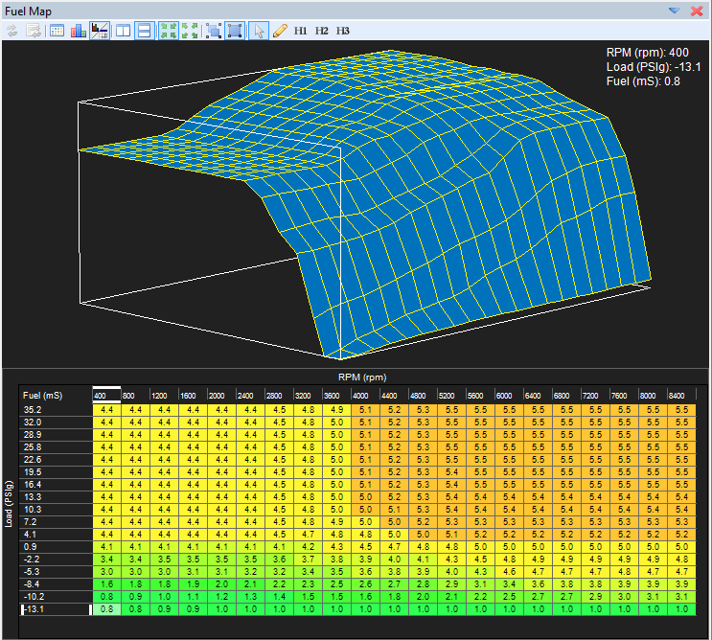

O2 Feedback
I personally use o2 feedback in AEM. Some people don’t. Some people use it just for building their fuel table, and then turn it off. A factory ECU is going to have 2 modes. There is closed loop (idle and low load situations) and open loop (under load aka boost ). The stock ecu and narrowband sensors will adjust how much fuel is being fed into the engine while in closed loop. Under load though they cannot read a wide enough afr range to be reliably be used. So the ECU switches to open loop mode. In open loop the ECU is reading from a special fuel table and not making any adjustments based off the o2 sensors.
Well AEM actually can make these adjustments even in open loop as it’s reading from a Wideband. If you want to use o2 feedback you need to add the “O2 F/B” tab to your workspace. It is just like it sounds. This table below is the target afr that you want to be at given a certain load/RPM. Then the AEM will read the wideband sensor(s) and make adjustments to the fuel to hit this targer AFR. The table below is actually one I built. At idle and cruising speeds I want to be at around 14.7 afr. Under high load I want to be around 11.5afr (forged internals and meth ).

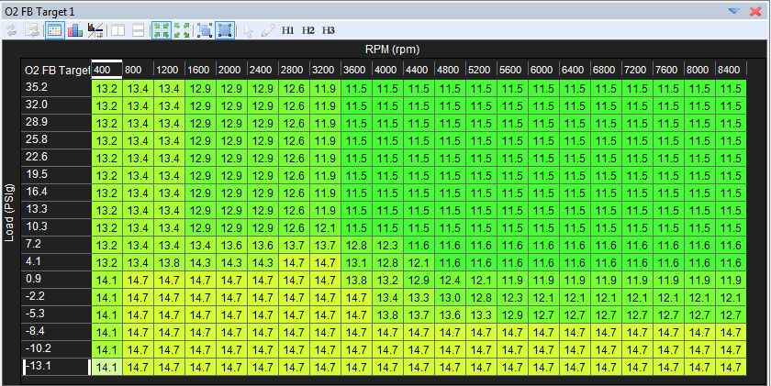

Here is a stock fuel map that was interprolated in aem from the factory ecu. This is from 3sgto member mb3000.

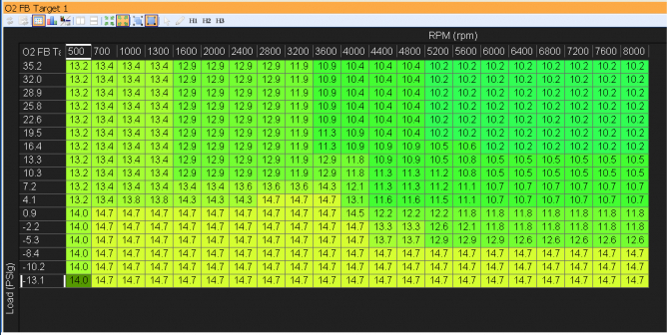

Now when using O2 FB, AEM is going to look at my current afr and my target afr. If they differ, AEM is going to add/remove fuel to try to real my target. How much fuel it trys to add/remove is set here.
O2 FB Control: On – This turns on o2 feedback. If it’s on then AEM will try add/remove fuel to help meet your target AFR.
O2 FB Lean Limit: This is the maximum percentage of fuel to remove if you are too rich to meet your target afr.
O2 FB Rich Limit: This is the maximum percentage of fuel to add if you are too lean to meet your target afr.
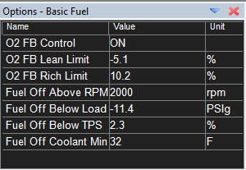
O2 Feedback can be really handy for building your main fuel table. When logging you will log “o2 target “ and and “o2 #1 FB Value”. This will show you realtime data about what targer AFR you should be trying to hit, and how much fuel is being added/removed to try to hit it. If you see that between 3k-4k rpms and 5-10psi range the “o2 #1 FB Value” is 8% then it means 8% more fuel is being added during this range to try and hit yoru target AFR.
Now you can go to your Main Fuel Table, find this same range, and increase the injector open time in ms; then repeat. The corrections AEM is making will get smaller and smaller as you correct your main fuel map. The goal is to see the AEM corrections go away, or stay low. When starting out you can set your O2 FB Lean and Rich limit to be larger (say -20, + 20). This will allow for larger corrections. However never rely entirely on O2 FB. Meaning don’t set high values here and forget it. You really want your Fuel table to be as accurate as possible, and for your Lean/Rich limit to be small. Otherwise if your wideband sensor ever fails, your afr ratio could quickly become unsafe.
When I built my fuel table I used o2 feedback initially. This helped me dial in a fuel map quickly. As the corrections came down to 6-8% range I turned off o2 feedback. This was just personal preference as I wanted exact control on fuel being add/removed. From here I dialed in my fuel map further. When I was happy with it I turned o2 feedback on again with a +-5% correction factor.

Changing Out Injectors
On my car I was hitting above 90% IDC with the PTE 680CC injectors. I swapped them out with PTE1000CC injectors. When you upgrade injectors in AEM you need to do 2 things.
- Select the appropriate Primary Injector in the Wizard. This will change the Battery Offset Primary table. If your injector is not listed you can contact AEM. They may have it on file from someone else. Or worst case scenario they will let you mail them an injector and they will calculate this for you. Here is a before and after shot of my table. 680s on the left, 1000s on the right.

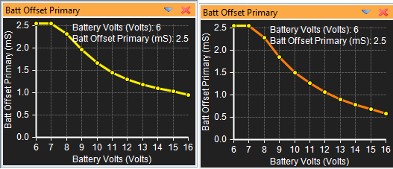

- Change Injector/Pressure Wizard. This will allow you to rescale your fuel tables. Since the 1000cc injectors flow more like 940s and 680s flow more like 650s, I’m using those values instead. This is true of PTE injectors, other injectors may vary. Apparently PTE tests their injectors at 80% duty cycle and interprolates what they would be at 100%. Their figures are always on the high side. You can also use this screen to increate fuel pressure. Say you are maxing your current injectors but just about maxed out on boost. You just want to squeeze a little more out of them. Then you would leave the injector flow values the same, and increase the new pressure. Then you can set your base fuel pressure on your fpr to be the new value.
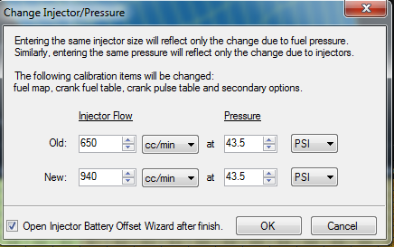
Here is a look at my 680cc fuel map
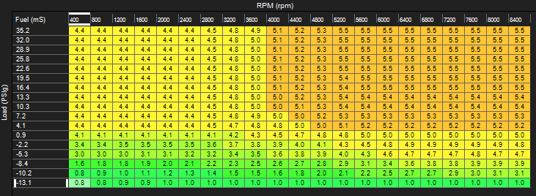
And here is the recalculated 1000cc one. It makes sense that the numbers are smaller. With a bigger injector you will want it open for less time to achieve the same amount of fuel as a smaller injector.
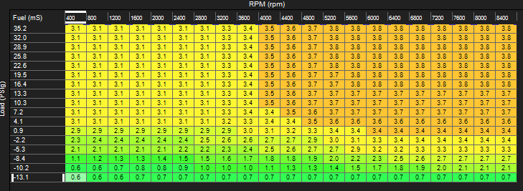
Also do not 100% rely on the injector change wizard. Always proceed with caution and do a few logs to tweak the fuel after. When I swapped mine out I still had a little fine tuning to do. But the wizard got me in the right ballpark.

Timing
The best thing about a standalone like AEM is that we can adjust ignition timing. Now with a combustion engine there are 4 stages:
Intake – This is where the intake valves in the head open and the Air/Fuel mixure enters the combustion chamber. The piston is traveling down creating a vacuum.
Compression – This is where the piston rises in the cylinder compressing the air/fuel.
Combustion – This is where the spark plug ignites the air/fuel mixture which will push the piston back down again
Exhaust – This is where the exhaust valves open up to let out the exhaust gases from combustion
Now when we discuss timing we talk in degrees. The degree refers to the position of the crank for the piston. When the piston is in its highest position we call that TDC or “Top Dead Center”. This would also be the 0 degree mark. Now we want the combustion to occur after TDC so that it will push the piston back down. You would think that you could tell the spark plug to fire a few degrees after TDC. However that is not the case.
There is always a delay between when you tell the spark plug to fire. The car signal needs to travel from the ECU, through the PTU/coilpack/Wires/Plug before the spark is actually made. Even after the spark is made, there is a small delay as the gas/oxygen ignites So in order to get the combustion to happen a few degrees after TDC, we actually have to start the chain of delays well before it. The number of degrees before TDC is what we refer to as timing. The higher the number the more “advanced” timing is. The lower the number the more “retarded”.

If your timing is too advanced you could be igniting before the piston reaches TDC. The combustion would want to slow the piston down and try to force it the other way. This is real bad for bearings, bad for creating power, and will cause bad knock. If your timing is too retarded then the combustion is not happening until long after TDS and the piston is already on its way back down. This isn’t bad per say, but it does mean a loss in power. Here is a good graph from online that outlines these points.

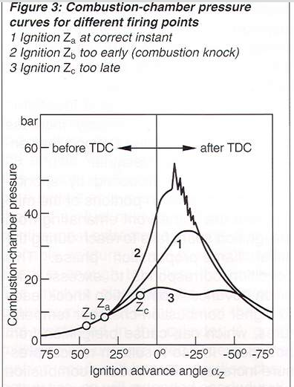

So in AEM the timing table consists of degree numbers. So at X RPM and Y load, the graph determines the number of degrees before TDC to start the ignition. Here is a look at the stock Timing Map. This was made by another member (mb3000) on 3sgto by interpolating the data from the stock Rom file.
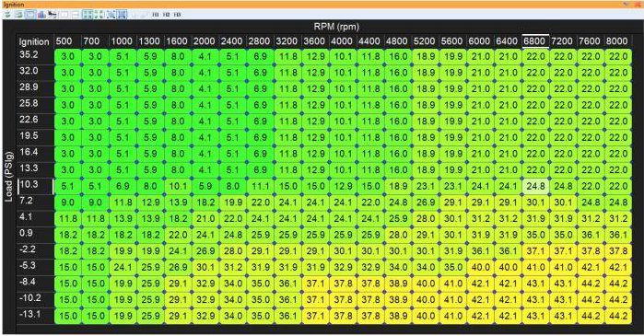

Timing is best tuned on some kind of dyno, and I wouldn’t try adjusting it without Knock Feedback enabled (which can retard timing automatically if it detects knock). Now the idea behind it is that we want to advance timing as much as possible before we start losing power and/or getting knock. When you advance timing, you want to do it little by little and no major advances. For example don’t try jumping an area of the table from 20 degrees to 25 degrees. It’s real common to read on the forums, “just keep increasing it until you start to see knock, the back it off.” While I have done this in the past at the dragstrip with a dsm, I wouldn’t recommend it, especially with Meth. We’ll go over Meth Knock real soon. The correct way to do it is to use a dyno. You want to keep increasing timing as long as you keep making power. When you get to the point where the extra timing isn’t creating extra power, then you don’t need that extra timing. Go back to what you had before or maybe try to split the difference. If you don’t have a dyno, I find that Virtual Dyno works really well to get you some extra power safely. We’ll go over that after discussing Meth Knock.

Meth Knock
Now why can advancing timing with Meth/Race gas be dangerous? Well meth can disguise/prolong the period until knock occurs. So you could be hurting your engine and not know it. This is known as “Meth Knock.” If you have stock internals you could eventually destroy the landrings on your pistons, or you could be wearing your bearings more than normal. This is true even outside of AEM. It’s worse for piggyback systems because they run more timing advance when fooling the ECU to correct their fuel problems. A piggyback hijacks the maf signal heading to the factory ECU and tells it less air is coming in. The ECU sees this and supplies less fuel. You want it to supply “less” fuel because you really have bigger injectors which are pushing more fuel in than stock injectors. Because the ECU is being fooled into thinking it’s not working as hard (aka under less load), it will be accessing the stock timing tables for that less load area. This means more timing as the factory ECU runs more timing at low loads. This combination of more timing due to piggyback, stock internals, and meth can be an expensive lesson learned. This is the major advantage of Stand Alone ECU’s like AEM. You can adjust the fuel without having an adverse effect on the timing. If you want to advance it without a dyno just be careful. Look at other timing tables out there to see what other people have done. Make small changes and be sure to log knock. If you want to be extra safe, maybe tune without meth, set your timing tables, then add meth and increase the boost by a few pounds.

Using Virtual Dyno

This is an awesome program that is surprisingly free. I don’t know how accurate the HP/Torque numbers are compared to a dynojet, but that’s really not the purpose. I use it for comparing one pull to another. As long as the power is increasing from one pull to another, it means your changes are positive. You can download it from www.virtualdyno.net Here’s how you set it up.
- Create a profile. Go to Profiles->Add Profile

- Select your car. Year is important in determining 5 speed versus 6 speed. The weight fills itself in. I subtracted a little as I have some weight reduction done. Enter your weight; select your tire size and it will calculate your tire height. Also select the gear you will be doing pulls in. I use 3rd as that is 110mph+ at redline. That’s bad enough doing street pulls. But it’s also the gear you spend most of your time in at the drag strip so I can’t think of a better gear to tune in.

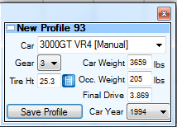

- Now before we can load a log, we need to get one from AEM Logger. It’s important to make sure you are logging the right things. Here is a shot of my 3rd gear pull. I’ve already gone to Graph->Zoom->Zoom In and grabbed around the pull area. AEM will log all the channels for whatever tab you are on. I stay on the “tuning” tab mostly.

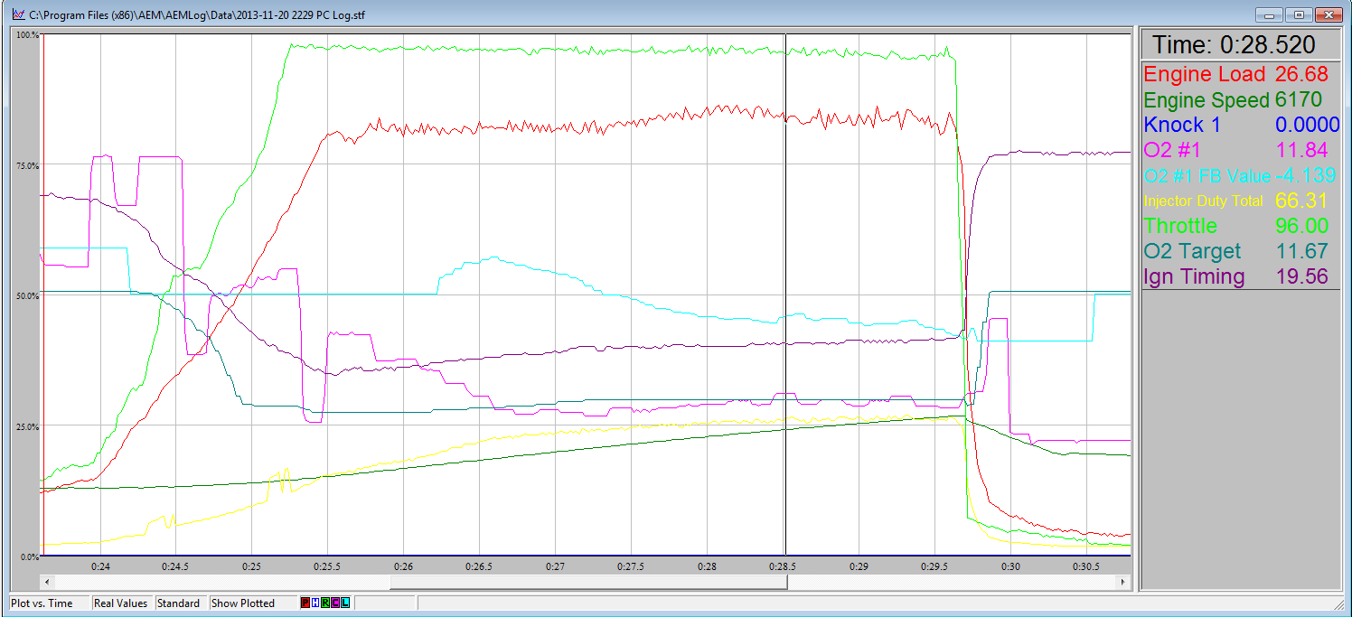

- Once you have the graph set go to File->Export as Text. It will ask you what you want to grab. You need to move the necessary values over to the right hand column. Make sure you select the “Current zoom area” radio button as well. These 6 values are what Virtual Dyno needs.

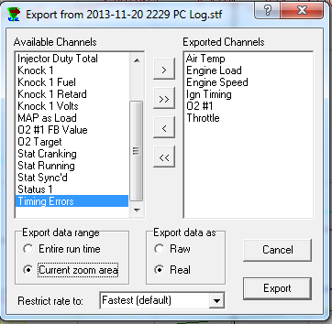

- In Virtual Dyno open the text file you just created. At the bottom of the screen select the profile you created.

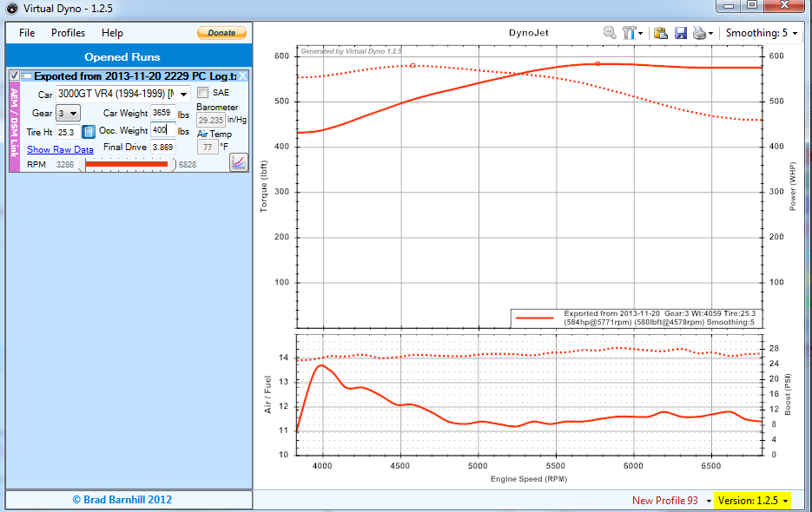

- At first it may look pretty good. That’s because “Smoothing” defaults at 5. At the top right set it to a smoothing of 1. This will give you a better visualization. Also click the “SAE” checkbox in the left hand pane and enter in the Barometer and air temp fields. You may need to use www.weather.com to grab the Barometric Pressure. When I did my pull it was about 25 degrees outside and the pressure was 30.6. Also I don’t weigh 400 pounds, I just had a friend in the car at the time

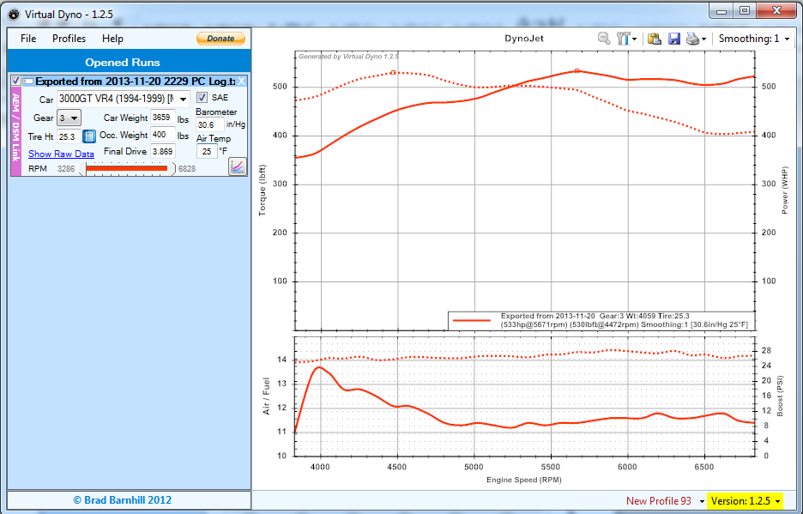

- So now here is a good baseline for me. I can see that the power kind of dips off around 5700rpms. I also have a little dip at around 5k rpms. Now I can make my adjustment in those areas to try to smooth it out. Also I can adjust overall timing as well. Then I can open my new pulls and overlay them on the same virtual dyno graph. Here’s a look of my last pull vs my first one. This one went from ~13 degrees to ~20 degrees in the 6500+ rpm 20-25psi load area. Note that I hadn’t taken in the SAE stuff yet, but you can already see the improvement.

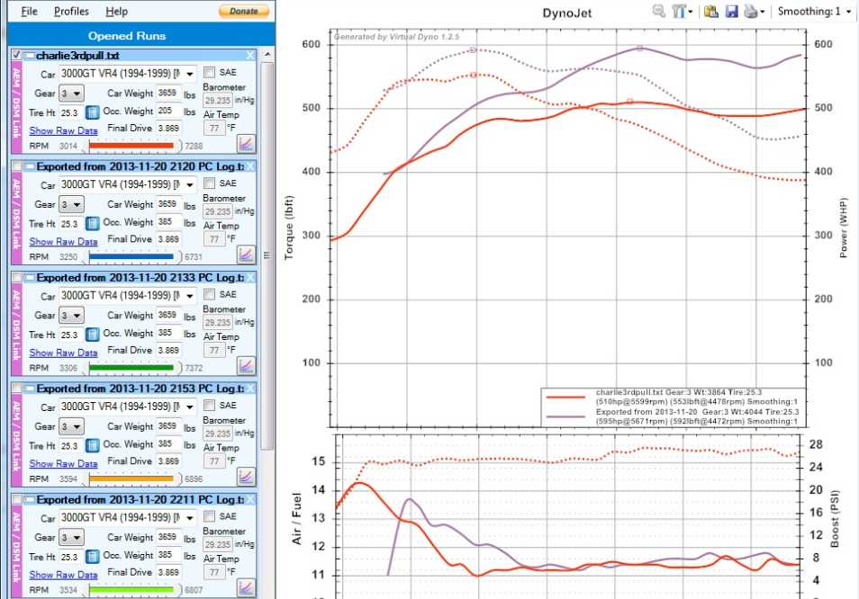

Knock Feedback
Knock Feedback in AEM is very important and can help save your engine. Basically when the car senses knock the ECU will add fuel and retard timing. Before you can start using Knock Feedback, you must setup your Knock Sensor Cal table. This is just a graph of knock volts vs rpm and acts as a baseline knock. Even under safe engine conditions your factory knock sensor is going to see noise. The higher the rpm the more noise it will see. This Knock Sensor Cal table is a graph of normal noise. So in my graph at 5600 rpms 1 volt from my knock would be “No Knock.” If my engine saw 1.1V at this RPM it would consider this Knock.

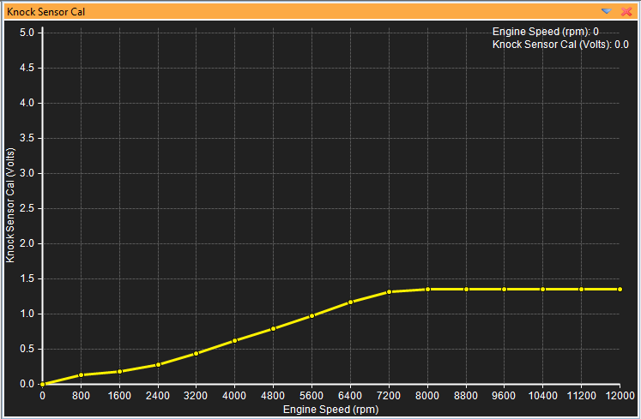

So every knock sensor/engine is going to read differently. It’s also normal for forged internals to have more “Normal” noise. To build this graph you are going to need to do about a dozen pulls in a safe environment. So with your boost down (I used wastegate pressure) and afr ratios safe; do some pulls and log rpm, afr, and knock 1 volts. Go through the logs and pull out the knock volts for each rpm. Add them to an excel spreadsheet. Now take the average Knock Volts for each RPM (some people just take the max which may be a better approach depending on how close they all are) and add 30%. This is a good baseline to use.
A good rule of thumb is 1.8-2.0V at redline with stock internals. My car has forged internals but seems to read a little on the low side. Every engine/knock sensor is different. Always use an OEM sensor and make sure it’s torqued properly. So using this spreadsheet I built the knock graph above. I smoothed it out slightly in the lower rpms and just continued the redline knock all the way up to 12000 rpms. AEM doesn’t allow you to adjust the X axis rpm points on this graph.
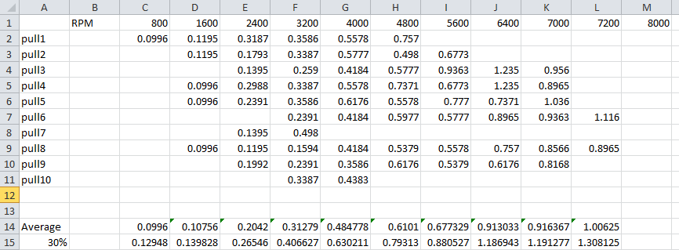
So now that we have the baseline set we need to tell it when to retard timing/add fuel, and how to add it back as knock goes away. AEM does a very good job explaining this if you have Tuning Explanation on. But I will describe them here using my own values.
Knock Control: On – This means I am using Knock Feedback
Knock %Rich/Volt: 5.0 %/V – For every knock volt 5% of fuel will be added..
Knock Fuel Add Max: 10.2 % - This is the maximum amount of fuel to add. So if I have 2 volts of knock over my baseline then I will add 10% fuel. If I have 3 volts of knock I will only add 10.2% fuel.
Knock Decrease Fuel: 2 % - This is the restore rate of fuel. So using the Knock Restore Rate below, if the car remains knock free for 73.8ms then 2% of fuel will be taken away. Another 73.8ms go by, then 2% more fuel is taken away. This will continue until all of the extra fuel added is taken away.
Knock Restore Rate: 73.8 ms - This is how long we must go without knock before we can start pulling fuel and increasing the timing.
Knock Retard/Volt: 2.7 degrees/V - For every volt of knock the timing will be retarded by 2.7 degrees
Knock Ign Rtd. Max: 9.1 degrees – This is the max amount of degrees to retard the timing.
Knock Spark Advance: 1.1 degrees – This is how many degrees to restore at a time given time. So every time the Knock Restore Rate of 73.8ms goes by without knock, 1.1 degrees will be restored until we are back to normal.
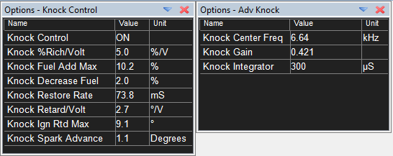
When logging with AEM Logger always log knock. You can log the Knock Retard and Knock Fuel items to see if the ECU is doing any kind of knock compensation. It’s also not a bad idea to log Knock Volts. The graph you made under “safe/low boost” conditions may also be safe but noisier at 30+ psi of boost. You may have to tweak your baseline if you find it’s reporting false knock. You can usually tell if knock is real or not by looking at the Knock Volts. If the up/down spikes follow the same trend it is probably normal engine noise. If you see one spike jump up outside the trend, then it’s most likely true knock.

NLTS/launch control
In AEM launch control is known as “2 step” and NLTS (no lift to shift) is known as 3 step. In v1 EMS 3step was known as “Rally Mode”. Both 2 step and 3 step work by having a 2nd and 3rd rev limiter. In AEM you basically tell it what RPM to cut fuel and ignition. You can actually have a different rpm for fuel and ignition, but I keep mine the same.
For launch control no additional wiring is needed. There is a vehicle speed field. So while the car is going under X mph, cut fuel and ignition at Y rpm. I have mine set to cut fuel and ignition under 4200 RPMS under 10mph. For the signal wire you must set this to “Always On”. The 2step Retard Rev can actually retard timing as well. We don’t need this to happen so just set it to an rpm that won’t be hit.
Edit: 1/12/2016 Having these 2step settings technically works, but it’s not ideal. I find that it’s slow when launching. My rpms will bounce from 4200 down to 3800. Depending when I let the clutch out the car would want to bog. I found that actually utilizing the 2Step retard Rev helped here. I forget my exact settings as they are still loaded on the ecu, but I’ll grab them later and update this section.
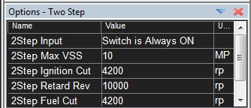

For NLTS we must go to the 3 step section. You technically could just use the 2step configuration for NLTS, but if you want to have a different NLTS RPM and Launch Control RPM then we need to configure both. You will notice that 3step Input is set to “Switch 3 Gnd=On”. If you look at the AEM wiring guide at the top, this is ECU pin # (put pin here). I ran a wire from my clutch switch over to this pin on the ecu. There are other switches available for pin inputs, but I know switch 3 works. I originally tried Switch 4 (pin put pin here), but it was not working. I researched on the aem forums and found that this was a known issue. To test the switch you can log “3Step” and/or “Switch 3”. Pressing the clutch pedal in should send a ground signal to the pin which will toggle these in the logger.

Now the 3step is not a single table value for cutting fuel and ignition. AEM allows you to cut at different rpms based on how fast the car is moving. This may be beneficial for rally driving, but we don’t need this for NLTS. To set a NLTS rpm point at 5500 rpm simply make all of the points on the fuel/ignition graph 5500. Similarly with the retard, set it to an rpm point that would never be hit. Make sure you turn 3step on as well. 2Step will always override 3step. So if you are sitting in your driveway trying to test a 5500 rpm stutterbox you will need to temporally turn 2tep off. Otherwise it will stutter at your 2step RPM.

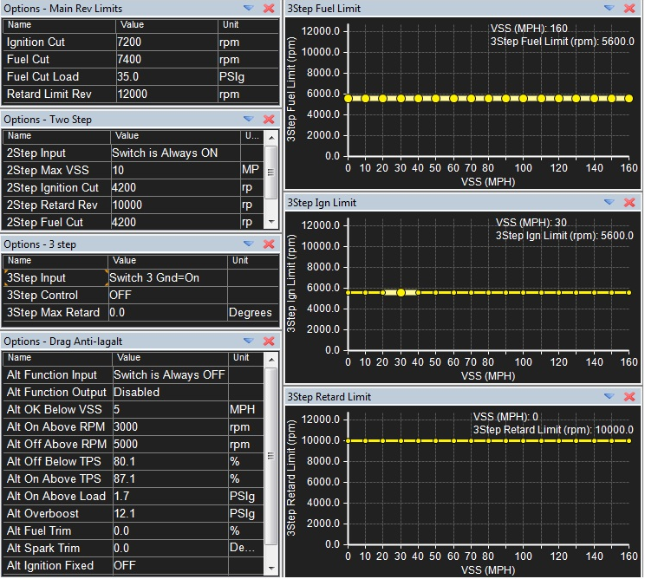

FAQs
- Can I remove my stock o2 sensors with AEM?

If you are using an aftermarket wideband gauge wired into O2#1 or O2#2 then yes you can. You can get 2 plugs for your manifolds from your local auto parts store.

- What pins are wrong in AEM’s diagram?

Pin 7 which is labelled as Switch #4 input does not work. It is actually Injector #10 output which isn’t used on a 3000gt.

Pin 43 which is labelled as a High Side Output also is not correct. While AEM advertises 4 High Side Outputs, the 3000gt EMS only has 3. Pin 43 is actually Switch #4 input

- My Car doesn’t seem to be making the power it should and I’ve checked everything!
I fell victim to this. Before becoming familiar with AEM I trailered my car 12 hours round trip to bring it to Ray at Pampena Motorsports. He attempted to tune my car and said it just wasn’t making the power it should for my mods. I brought the car home and double checked EVERYTHING. I boost leak tested, I removed my high flow cat and replaced it with a resonator, I double checked my timing marks, double checked my it was synched with a timing light, pulled my valve covers to confirm the cam gears were installed right, did a compression test, etc… I was dumbfounded.
I continued to play with the tune on my own. I upgraded the firmware, installed bigger injectors, rescaled my tables, redid my fuel map, and started adding timing. What I found was that I wasn’t knocking but I was running 23-24 degrees of timing. I know this is approaching borderline the limit that other people run. Then all of a sudden I learned about “Pickup Delay Comp.”
I haven’t tested it yet because its winter, but this has to be my issue. I have a 2g so my Pickup Delay Comp should be set to ~130 microseconds. But the base map that AEM delivers for a 2g actually has the 1g value in there of 49.6 microseconds. With this value wrong it means that even though my ignition timing synchs fine at low idle rpms, it becomes off at high rpms. By having it set lower than it should be it means I’m running about 5-6 degrees less than I think I am. So where I’m running 23 degrees at around 6krpms, it’s really more like 17-18 degrees. This would explain why I’m not approaching knock when logging, and why my car didn’t seem to make the power it should have. Or so I hope! I’ll update this in the spring.

